I’m trying to figure out how to create confidence intervals for slopes in a piecewise model.

The data were collected over 14 days and I have three stages specified (Days 1-6, 7-10, and 11-14) for the piecewise model (I want to estimate unique trajectories/slopes for each stage). So I have the following variables that code for each stage:

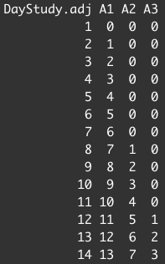

The simplest model (no covariates) includes an initial intercept and a slope for A1, A2, and A3 with subject as a random factor and all random slopes. The outcome is negative affect reported on each day.

NA_agg ~ 1 + A1 + A2 + A3 + (A1+A2+A3|SubID)

The output in R for the fixed effects looks like:

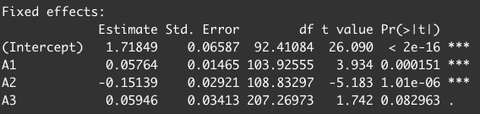

So these results tell us:

* The initial intercept of NA on Day 1 is 1.72 (on a scale of 1-5) (significantly higher than 0)
* The slope for Stage 1 is .058 (significantly different from 0 and a positive slope)
* The slope for Stage 2 is -.094 (estimate for A1 plus estimate for A2, slope for A2 is significantly different from slope for A1)
* The slope for Stage 3 is -.034 (estimate for A1 plus estimate for A2 plus estimate for A3, slope for A3 is not significantly different from slope for A2)

The way the model results come out, the significance tests for A2 and A3 test whether the slope in each stage is different from the slope in the previous stage. But I want to test for significance (and/or compute CIs for the slopes of Stage 2 and Stage 3). Any ideas on how to do that or how I can mathematically combine/compute the SEs that I’ve been given for these parameters into SEs for the slopes?